***FLORIDA SCHOOL COUNSELOR ASSOCIATION (FSCA)***

## Convention Exhibiting and Sponsorship Opportunities

***November 13-15, 2025***

FSCA invites you to participate as a sponsor or exhibitor at the Florida School Counselor Association’s 2025 professional development convention: Florida’s largest gathering of school counseling professionals annually.

This year, the Florida School Counselor Association welcomes school counselors, licensed counselors, counselor educators, counselor supervisors, school counseling graduate students, FL Department of Education, and industry experts to share best practices, curricula and research on methodologies best suited to support our student populations.

Exhibitors are set up for centralized access to attendees, providing you with the opportunity to share how your organization can fill the needs of school counselors to better support K-12 students.

The Florida School Counselor Association purposefully builds our schedule to maximize vendor and attendee interaction opportunities, something critical for you to showcase your brand. With numerous receptions, general sessions, and breaks scheduled in the exhibit area, you will experience high traffic volume and motivated educational professionals.

## Location

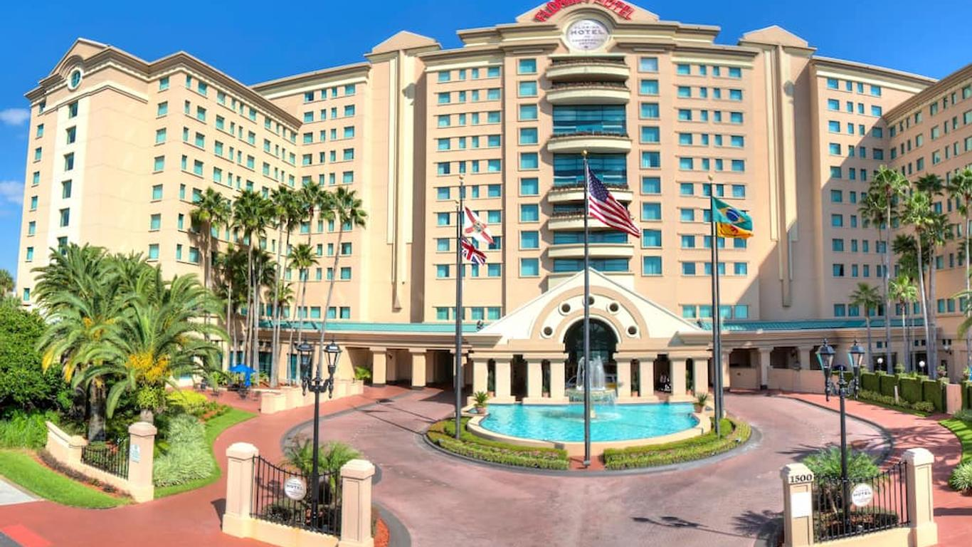Our 2025 convention will be held at The Florida Hotel and Conference Center, 1500 Sand Lake Road, Orlando, Florida 32809. A block of rooms has been reserved at a special rate of only $156 per night (includes $5.00 charge for parking) for either single or double occupancy

This limited-time discount i.s available November 9 through November 18, 2025 (based on hotel availability). Reservations must be made by October 22, 2025 to obtain the discounted rate.

To reserve your room, visit our webpage and/or click on the [FSCA 2025 Convention Hotel Booking Link](https://thefloridahotelorlando.reztrip.com/ext/promoRate?property=1775&mode=b&pm=true&sr=960657&vr=3)

# Exhibiting

Exhibiting at the Florida School Counselor Association’s annual convention provides you with the ideal environment to showcase your products and services.

## Why Exhibit at FSCA?

* Debut new offerings
* Build brand recognition
* Expand company sales
* Increase market exposure
* Generate referrals and leads
* Consult with industry experts
* Meet stakeholders face-to- face
* Strengthen existing relationships
* Showcase products and services

## Exhibitor and Sponsor Benefits

* Opening reception planned for the exhibit hall
* Coffee and snack breaks in exhibit area with attendees
* Company logo and summary in the attendee program
* Traffic flow of empowered buyers and key influencers
* Opportunity to provide flyers which will be placed in attendee convention bags
* Opportunity to provide company-supplied promotional products which will be placed in attendee convention bags (such as water bottle, USB drive, pens, notepads, etc.)
* Opportunity to provide a video that will be imbedded in Exhibitor Recognition presentation at each General Session (subject to availability)
* Electronic mailing list of convention attendees
* Pre- and post-convention promotion via FSCA email blasts
* Recognition in November FSCA Weekly Bulletin

# Exhibit Tables

Exhibit tables are comprised of one six-foot by two-foot draped table, two chairs, and one wastebasket. Thirty days prior to the convention, each exhibitor will receive an Exhibitor Kit, which includes forms to request (at additional cost from the hotel)

* Audiovisual equipment
* Application for electrical utilities, telephone, and other services
* Additional booth furniture
* Drayage and shipping information

# Conference Sponsorship

Sponsoring the Florida School Counselor Association’s annual convention provides you with the rare opportunity to maximize the visibility of your brand throughout the duration of the event and beyond. Levels range from Platinum to Gold to Silver, with additional opportunities to sponsor Tote Bags, and Meal Functions.

No matter your marketing budget or promotional objective, we are here to help.

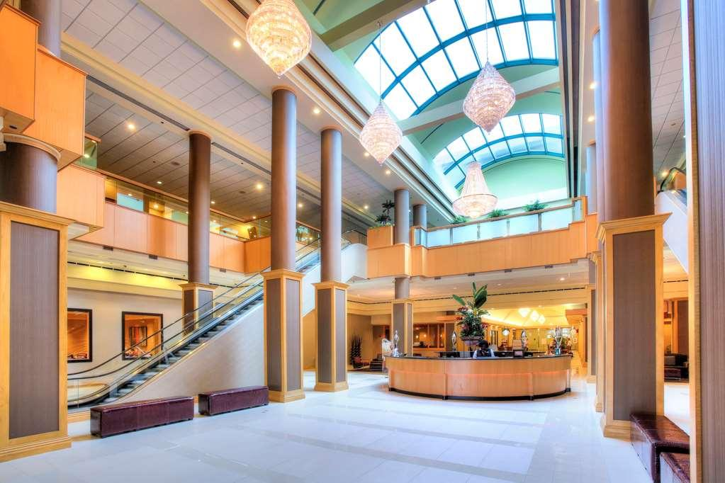

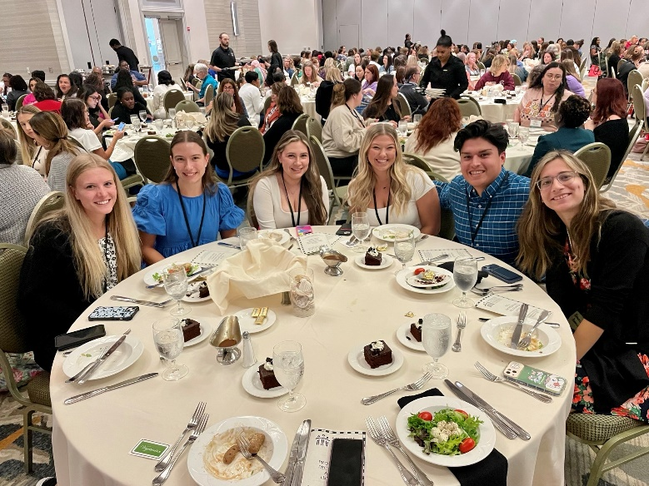

***Over 400 School Counselors Expected to Attend!***

## Platinum Benefits

* Highlighted as a Platinum sponsor in the Exhibitor area
* Four full convention registrations, which includes the luncheon
* Opportunity to provide a flyer and company- supplied promotional products which will be placed in attendee convention bags (such as water bottle, USB drive, pens, notepads, etc.)
* Six-foot exhibit table, PREMIUM LOCATION
* 30-second video imbedded in Exhibitor Recognition presentation at each General Session (subject to availability)
* Reserved seating during awards luncheon (Friday)
* Company logo featured on table during awards luncheon (Friday)
* 1-page recognition in the 2026 Winter Issue of the FSCA Newsletter

## Gold Benefits

* Highlighted as a Gold sponsor in the Exhibitor area
* Three full convention registrations, which includes the luncheon
* Opportunity to provide a flyer and company-supplied promotional products which will be placed in attendee convention bags (such as water bottle, USB drive, pens, notepads, etc.)
* Six-foot exhibit table, PREMIUM LOCATION
* 20-second video imbedded in Exhibitor Recognition presentation at each General Session (subject to availability)
* Reserved seating during awards luncheon (Friday)
* Recognition in the 2025 November FSCA Weekly Bulletins (4 issues)

## Silver Benefits

* Highlighted as a Silver sponsor in the Exhibitor area
* Two full convention registrations, which includes the luncheon
* Opportunity to provide a flyer and company- supplied promotional products which will be placed in attendee convention bags (such as water bottle, USB drive, pens, notepads, etc.)
* 10-second video imbedded in Exhibitor Recognition presentation at each General Session (subject to availability)
* Reserved seating during awards luncheon (Friday)
* Recognition in the 2025 November FSCA Weekly Bulletins (2 issues)

## All Exhibitors

* Name badge and sponsor ribbon for company attendees
* Access to convention events (sessions, general session, etc.)
* Luncheon Tickets (number based on level of sponsorship)
* Opportunity to provide flyers which will be placed in attendee convention bags
* Electronic mailing list of convention attendees
* Pre- and post-convention promotion via FSCA mail blasts
* Recognition in the 2025 November FSCA Weekly Bulletins (1 issue)

**Exciting Feature for Exhibitors!**

Exhibitors will be offered the opportunity to give more in-depth information about their product or program on Friday, 6:00pm - 6:45pm as a presentation in the ballroom. Convention participants will sign up with the exhibitor of interest during the Thursday Opening or on Friday between sessions. They will then attend the exhibitor presentation from 6:00pm – 6:45pm. After the presentation, exhibitors will give participants Saturday drawing tickets for the Convention closing.

# Additional Sponsorship Opportunities

## Food Station Sponsorship

* Snack Table Sponsorship (Friday and/or Saturday)
* Breakfast (Friday and/or Saturday) Sponsorship
* Friday Award Luncheon Sponsorship
* Your firm's name and logo will be featured along with verbal recognition by convention organizers
* This is a sure way to highlight your contribution to the convention.

## Convention Tote Bag Sponsorship

Your company's name will be the one every attendee is sure to go home with, knowing that you sponsor the official convention tote bag. All attendees will receive this special carry-all bag to hold their convention materials. Take advantage of promoting your company on the bag itself, which will also display the Florida School Counselor Association logo.

* Sponsorship is limited to ONE organization
* Your firm's logo will be featured on the bag displaying the conference artwork
* Bags will be chosen and ordered by FSCA Convention Committee.

**Convention Website Sponsor**

* Your company’s name and logo will be seen each time anyone views the convention home page on our website plus each separate tab on the convention home page. Hundreds of school counselors, potential exhibitors and sponsors will know that your company supports school counselors and has opportunities for students.

**Awards Program Booklet**

* The annual awards event occurs during the formal luncheon. Your company’s name and logo will be featured prominently on the awards program which is provided to all convention attendees, plus distinguished guests, and guests of award recipients. With such high visibility as part of a special event, your organization will be promoted well after the convention concludes.

## Saturday Drawing

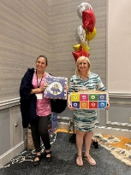ALL exhibitors and sponsors are encouraged to enter items for the drawing that will take place on Saturday, November 9 at 11:30 am. Organizations will be highlighted as the donor when items are displayed during the convention and also when items are awarded to recipients.

# Pricing Summary

## Exhibitor and Sponsorship Levels

* Exhibitor $900
* Additional 6’ x 2’ tables $500 ea. (based on space and availability)
* Silver Sponsor $2,300
* Gold Sponsor $3,800
* Platinum Sponsor $5,300

Exhibitors who reserve their spot and pay prior to **July 31, 2025** will receive a ***10% discount*** on the cost of their exhibit fee (which includes additional tables). This discount does not apply to any fees paid directly to the Hilton hotel, nor to any Additional Sponsorship Opportunities (listed below).

## Additional Sponsorship Opportunities

*(in addition to one of the levels above)*

* Friday Breakfast Buffet $1000
* Saturday Breakfast Buffet $1000
* Entertainment $1000
* Convention Tote Bags $1200
* Friday Snack Station $1400
* Saturday Snack Station $1400
* Friday Award Luncheon $1000
* Keynote Speaker (Contact for more information)
* Award Program Sponsorship $700
* Convention Website Sponsor $1000

## Important Dates

*Thursday, November 13*

Set up: 1:00 pm - 5:00 pm

Open: 6:00 pm - 8:00 pm (Opening Reception)

*Friday, November 14*

Open: 7:00 am (During Breakfast)

Awards Luncheon: 12:15 pm

Exhibitor Presentations: 6:00 pm - 6:45 pm

Close: 6:00 pm (Dinner on Your Own)

*Saturday, November 15*

Open: 7:00 am (During Breakfast)

Drawing: 11:30 am

Close: 12:00 pm (End of Convention) and

Tear Down: 12:00 am - 1:00 pm

# Convention Exhibitor and Sponsorship Benefit Summary

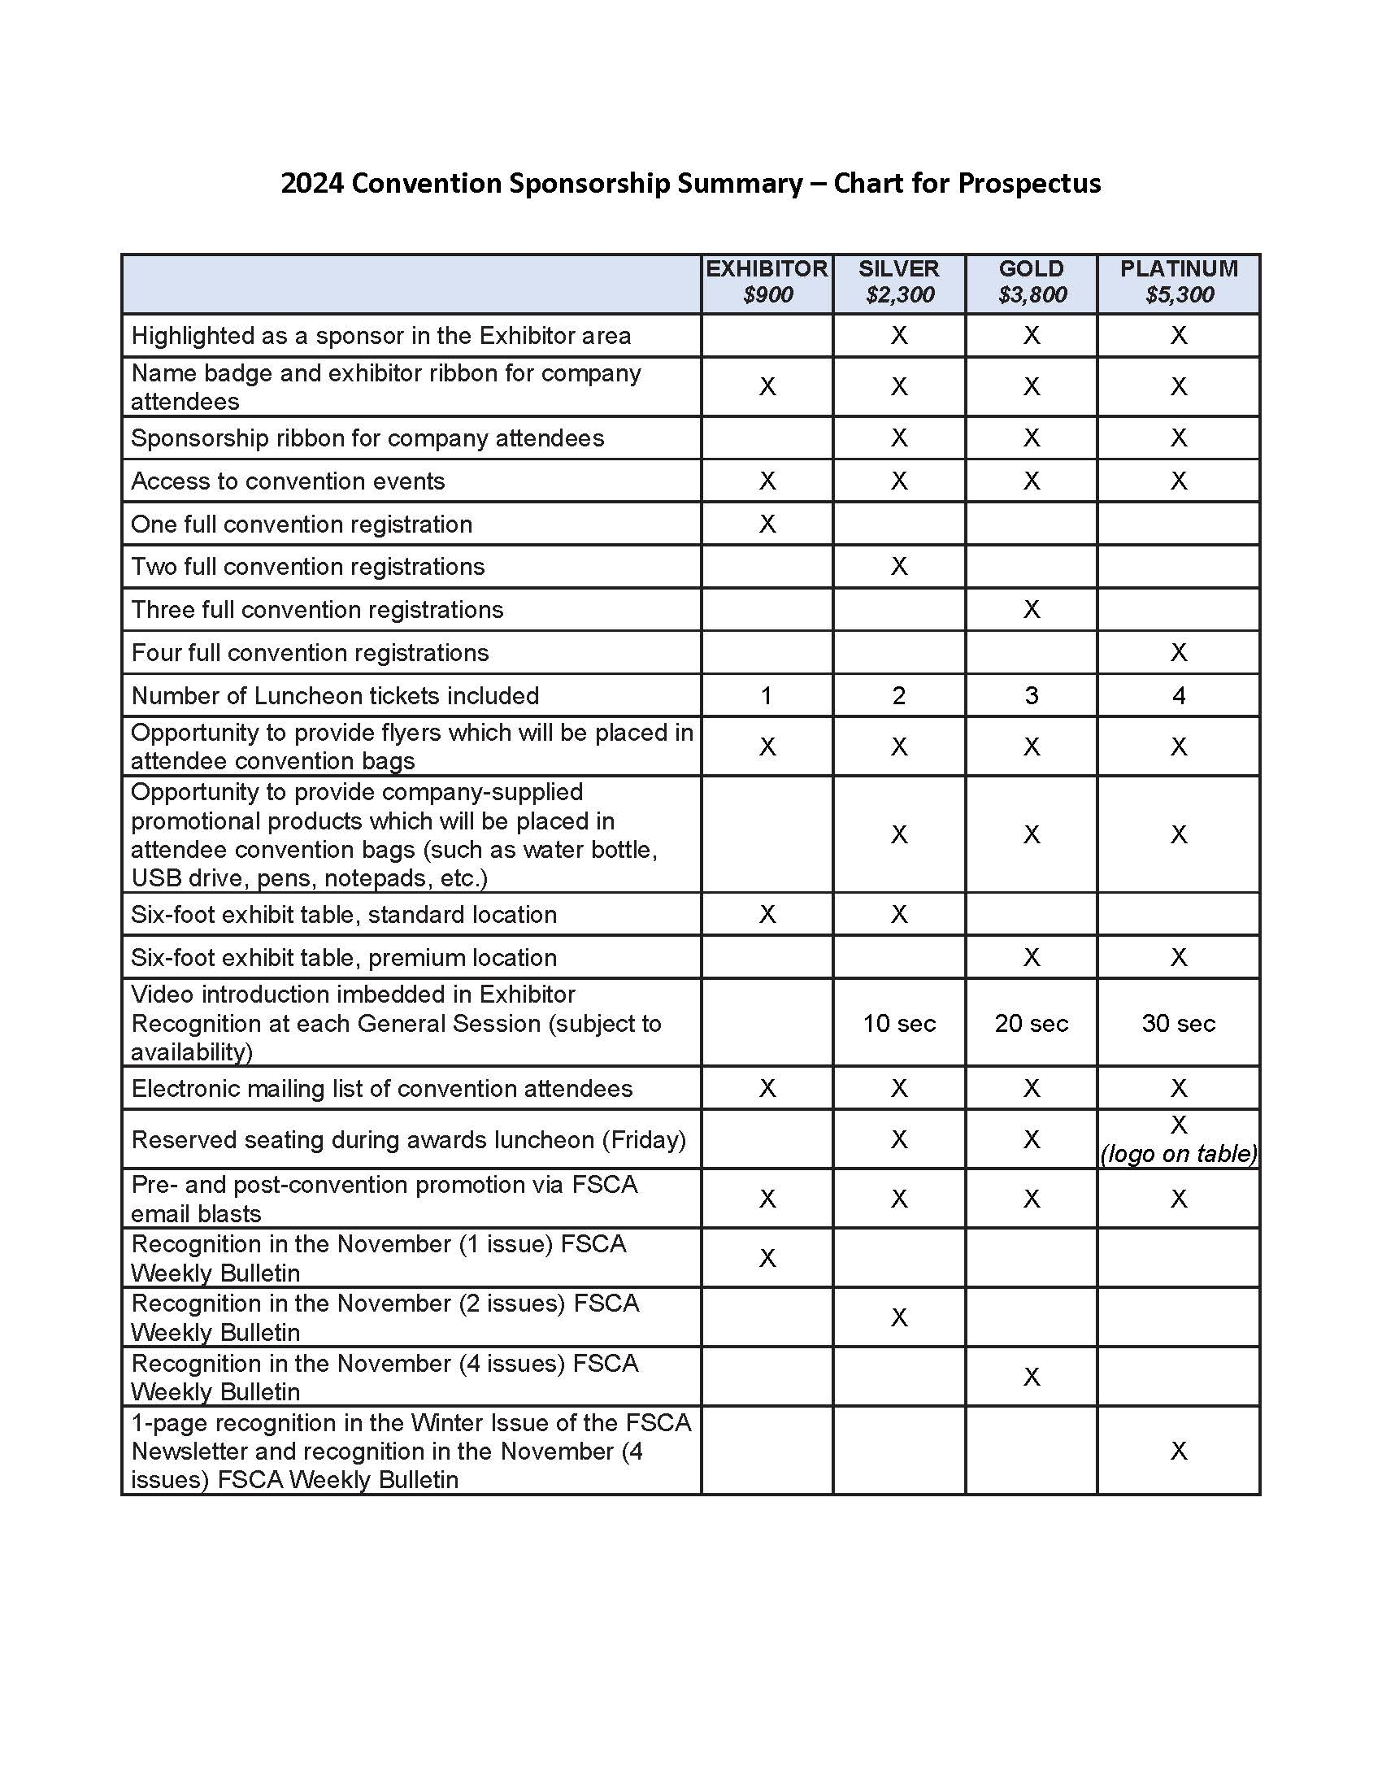

*“The Florida School Counselor Association supports the school counseling profession through continuous learning, advocacy, and collaboration ensuring that our collective voice provides the highest level of support for equitable student success”* (FSCA Mission)